ETAD Lab – 3D printing SOP

Flashforge Creator Pro Manual
Click Flashforge Creator Pro link to access manual
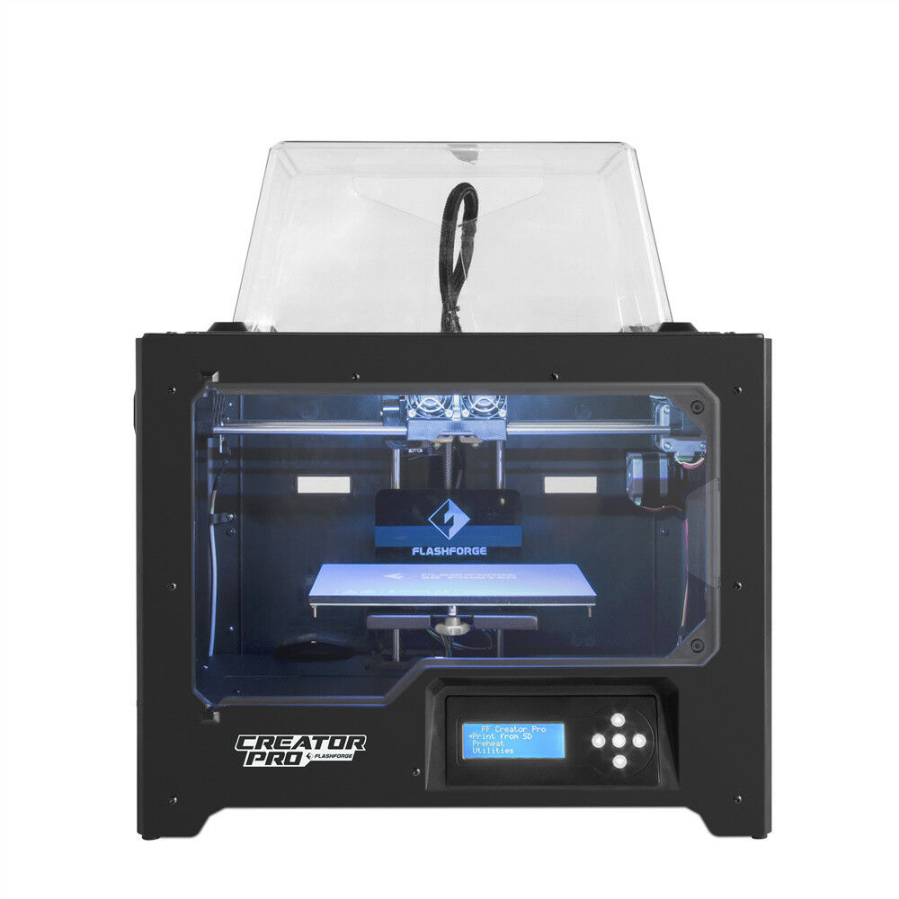
Figure 1. Front view
Table of Content
ETAD Lab – 3D printing SOP 1
1. Features 3
2. Material 6
3. CAD - Computer Aided Design 7
4. G-code 7
5. Slicing 7
6. Operation 9
7. Post Processing 13
8. Maintenance 13
9. Troubleshoot 14
10. Useful resources 14

Features

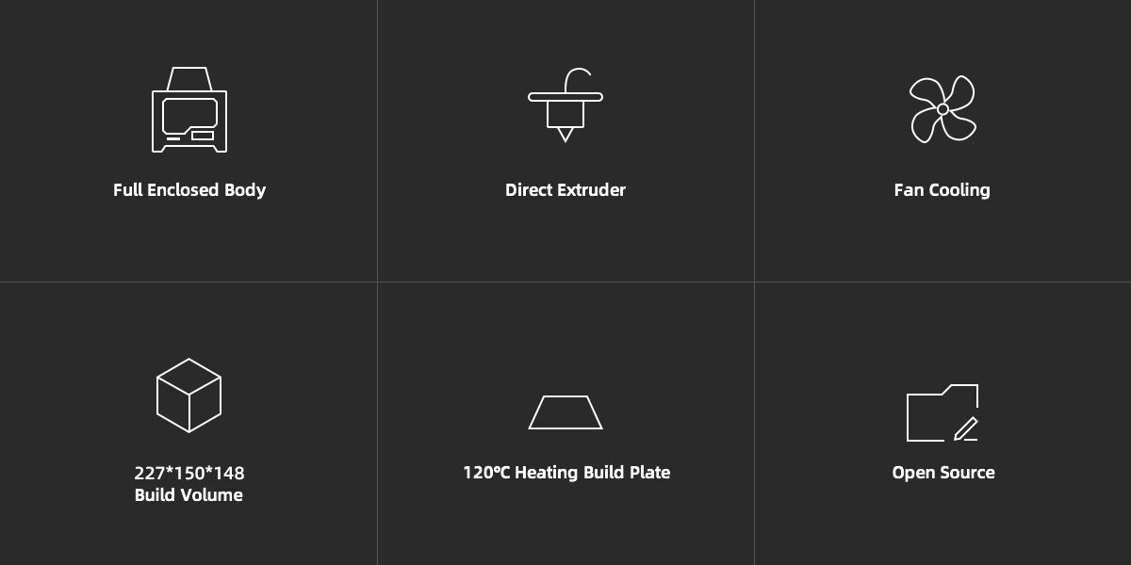
Figure 2. Six features
  - Dual Extruder
    - Currently, the 3D printer in the ETAD lab allows only one or the extruders to be operable at a time, which means one of two extruders must remain disabled during printing.
    - To reach optimal 3D printing performance, two extruders can be present but only one extruder can be equipped with a nozzle. Click the superlink for the nozzle disassembly tutorial.
    - In theory two extruders, both left and right, can operate at the same time. However, tedious extruder calibration is required since dual extruding requires PERFECT clearance distance between BOTH extruders and the heated bed. The nozzles must align, otherwise, the lower one will shred the print. This author had constructed several experiments with little success. Any further experiments are encouraged. Here are the steps.
      - Obtain the Balance Block
        - Purchase one on eBay (since it is sold on eBay, Calit2 will not purchase it)
        - 3D print one (Not recommended but Good Luck!)
      - Disassemble the extruding machine then calibrate both nozzles
        - With Balance block:
          - Follow steps in the tutorial
        - Without Balance block by using this trick:
          - Do all the steps in the tutorial except the balance block calibration part. You should separate the extruder (Refer to figure 3) from the chassis.
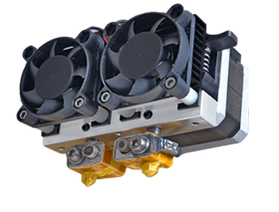
Figure 3. Extruder
          - Lower the print head so the protruding nozzle can BARELY touch the print bed (Be CAREFUL or you may permanently damage the print bed).
          - Loosen both screws of the print head mechanism (the red block in Figure 4) so both nozzles can touch the print bed.
          - Complete the rest of the steps in the tutorial.
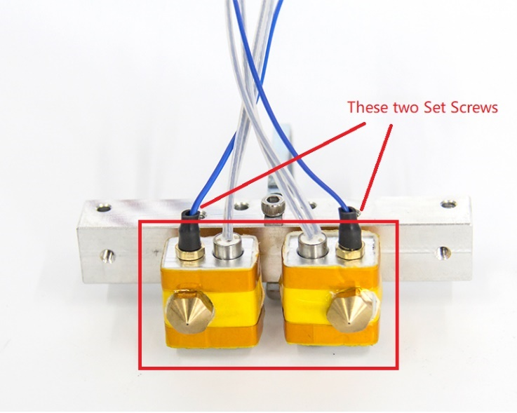
Figure 4. Take extra caution when working with fasteners. Overtighten or overexert may leave permanent damages.
      - Restore the printer
      - Happy dual extruder printing!
      - Comments:
        - This author made no success using other nozzle grounding or leveling method, such as using some calibration tools from FABWorks, etc. However, if you have access to a balance block and calibrate both nozzles PERFECTLY, you may begin exploring the art and joy of dual color/material 3D printing. Wish you good luck!
  - Heated Bed
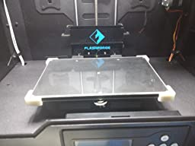
Figure 5. Ideal glass mounting example
    - Currently, a glass plate is locked on top of the heated bed by three paper clamps. However, example in figure 5 is recommended since paper clamps can intervene some operation of extruder.
    - Mount a glass plate on top of the heat bed has several benefits like shortening the cooldown time, heated bed protection, etc. This author places a layer of PEI sheet on top of the glass plate for viscosity enhancement.
    - However, in theory, there are protentional performance drawbacks since an extra layer of medium may influence the thermodynamics. This author had not experienced any related problems but there are some heated bed upgrade methods that are worth a try. For example, Prusa i3 MK3S magnetically fixed a piece of removable steel spring sheet on top of the heated bed. Such mechanism achieves high convenience while remains thermal efficient. Do you research and have fun!
  - Full Enclosed Body
    - Always keep the enclosure closed for printing ABS.
    - Only open the door and remove the top cover for maximum ventilation for live PLA operation. Keeping the printer dustproof is always recommended.
  - Factory Spare parts:
    - Many useful tools and part replacements can be found in the cabinet labeled as “3D printing”

Material
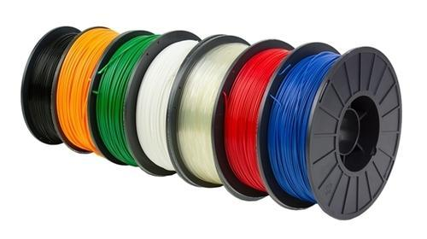
Figure 6. Filament spools
  - PLA and ABS are the most common thermoplastic used for 3D printing. Research and experiment are required to fully understand how each material behaves under different circumstances. Their pros and cons can be smartly targeted for desired application.
  - Besides PLA and ABS, composite filaments are sometimes used for special application. For example, PVA can be used as support material for PLA prints since PVA is dissolvable in water
  - This author recommends these providers:
    - Matterhackers
    - Ultimaker
    - Proto-Pasta
  - This tutorial is a great filament type 101.
  - ETAD lab is equipped with a decent amount of PLA, ABS. They can be found in the dry box located in 3D printing Station.

CAD - Computer Aided Design
  - Open source files
    - Thingiverse is a popular online community for creators to share user-created digital design files. A variety of files are 3D print friendly, like phone case files, organizer files, etc. However, unless the design files are appealing in both design and functionality, self-designed parts should be prioritized.
  - Customized files
    - CAD Background is highly recommended for creating customized files. Common CAD software includes Solidworks, Autodesk Inventor, and Autodesk Fusion 360. ETAD lab is equipped with Solidworks and Autodesk Inventor. Same sample CAD files can be found in the google drive as well (If you are looking specific guideline for specific projects, you can find a list of documentation in the google drive as well).
    - If you have no experience using CAD, start with Autodesk Fusion 360 since it is free. The following tutorials are recommended to start with.
      - Getting Started with Fusion 360 - Autodesk

G-code
  - Files that end with .gcode is the file name created by most common slicing software. There is NO NEED to learn G-code now for 3D printing beginners since slicing software can do it ALL for you. Reducing coding load was the main reason why computer scientists created slicing software in the first place. This computer language will tell the 3D printer what to do line-by-line. Just like other computer language, G-code can be written from sketch in any plain text editors, but the process will be extremely tedious and repetitive. This code library contains the all the information if anyone wants to dive in deeper into coding.

Slicing
  - Purpose:
    - Slicing is the process that makes CAD files understandable for 3D printer. Human brain is sensitive to shapes and dimensions, so CAD files are created and stored for communication and knowledge exchange. However, 3D printing machine can only read codes and follow operation. Therefore, engineering must slice the CAD files through slicing software while adding their production instructions.
  - Software:
    - This author had experience working with Simplify3D and Cura. They can both accomplish major slicing goals and tasks with their own specialties. They are both available for Calit2 students: Simplify3D is licensed by Calit2 while Cura is a free and open source software. In this author’s opinion, Simplify3D has a better user experience and UI design, so it will be the center of the discourse.
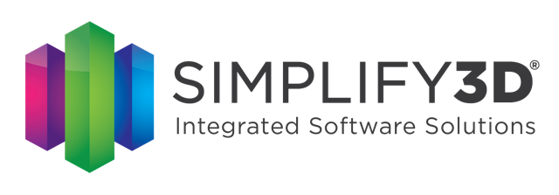
Figure 7
      - This software is not hard to use after the fundamentals are learned. There are many of useful beginner guides on the internet. Here are several useful ones to start.
        - https://www.youtube.com/playlist?list=PLogLRK5xzNdieu445p2O7wODJpQBVf-Ss
        - https://www.simplify3d.com/support/tutorials/
      - This author has created and saved several default profiles for you to start with. These profiles include specific setting regarding different materials, print quality, production requirements, etc. Use the default Simplify3D profile created by this author for your FIRST print work. DON NOT MODIFY the default profile. CREATE A SEPARATE PROFILE for any further experimentation! You may find these profile in the google drive.
        - After you get a feel of Simplfy3D, this author believes the following tips will be beneficial.
          - Set your profile and don’t change it unless necessary. Then, under your profile, create various process to meet to your production goal. It is important that you organize your setting well when you are working with various materials and more than one 3D printer
          - Don’t take any solution online as a guarantee. There are almost no identical 3D printers, so the solution works for others may not work for you. Experiment with your educated guesses is the only way that can answer your concerns.
      - After slicing:
        - Congratulations! You are ready to 3D print on Flashforge Creator Pro (refer to as FCP). However, be prepared for failures! Improper calibration, CAD model, or slicing profile can all cause failures. It may take several attempts before you get what you want as it would be a stroke of luck to get it right the first time without any tweaking.

Operation

Operation flowchart

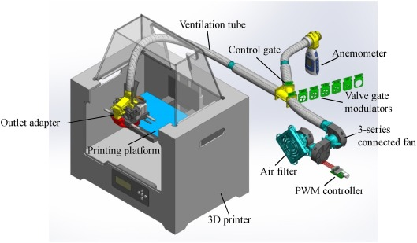
Figure 8. Flowchart of operation
  - First layer:
    - First layer’s importance is like a good foundation to a skyscraper. Without a PERFECT first layer, your print job may fall due to layer dislocation, elephant foot, etc.
    - Temperature, bed viscosity, are all key determinants. Use the default Simplify3D profile created by this author for your FIRST print work. RECORD and SAVE the default profile before any further experimentation.
    - This author had experimented several adhesion enhancement methods, including blue tape, glue sticks, hairspray, etc. What works the best, according to this author’s experience, is PEI sheet. It looks like figure 9. Refer for Maintenance section for more information.
Figure 9
      - For more detailed guide, refer to this guide.
  - Before you start:
    - Make sure FFP is correctly maintained! Refer to Maintenance Section for further ado. Remember, NEVER 3D print without a PERFECT FIRST LAYER!
    - Check how much filament is left from last print! Always leave MORE filament than you need! Currently there is no material measuring mechanism set up for gauging. However, information in Build Statistics from Simplify3D (red box in figure 9) may provide you with an estimate on how much material you need.
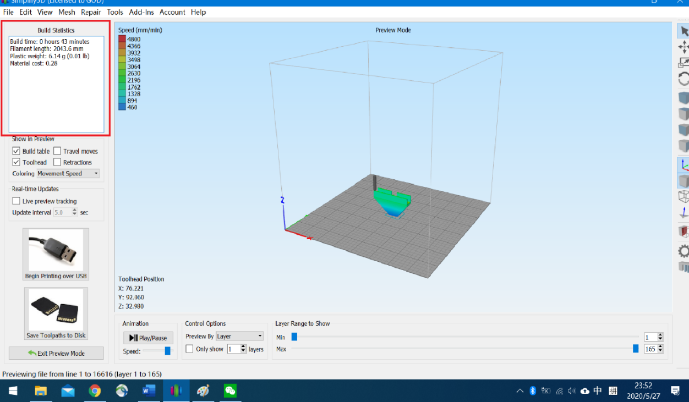
Figure 10
  - Digital Control
    - Currently, Flashforge creator pro is connected to the PC through USB cable. This gives operator freedom to do several things. First, the operator may obtain more printing data and feedback. On top of it, operator may implement some advanced features. For example, resume a partially failed print, make maintenance easier, etc.
    - Here are the steps
      - Turn on the Flashforge Creator Pro
      - Wait for the machine to get ready indicated by the blue LED screen and an alarm sound.
      - Go to your computer and click connect on your Simplify3D setting page.
      - Test the connection by moving the extruder or hotbed through jog control page
      - Prepare enough filament for your print job
      - Once your file is ready, click print with USB.
      - Check your PC setting. It is important that your PC NEVER go to sleep mode! This setting can be found in the battery setting of your PC. If your computer sleeps in the middle of a print, your 3D printer will PAUSE printing!
  - Manual Control
    - Not recommended but here are the steps.
      - Turn on the Flashforge Creator Pro
      - Wait for the machine to get ready indicated by the blue LED screen and an alarm sound.
      - Take out the SD card from the printer and insert it properly in your computer port
      - Once your files are ready, click “save path to SD card” option. Notes: Always put your file in the desired folder. Otherwise it will be hard to find you G-code file in 3D printer interface.
      - Prepare enough filament for your print job.
      - Eject your SD card safely from your PC and put it back in 3D printer.
      - Choose “Print with SD Card”. Find your file and click it. Then the 3D printer will do its job.
  - Common operational failures.
    - Filament Shortage
      - The slicing software provides you with an approximate amount of filament for your print job. Make sure you prepare your 3D printer with enough filament every time before your print job. When your filament runs out before your print job finished, you will unfortunately end up with an incomplete print. Currently, FCP does not have any build-in mechanism to prevent this from happening.
      - If you are lucky enough to observe filament shortage during your print, there are couple ways to save your print. This tutorial will give you a general idea.
        - For digital control operation, you may use jog control in setting to pause/resume your print or unload/reload filament.
        - Before the filament runout, you need to click Pause (red 1 figure 10). This will stop the print. Before unloading or reloading any filament, memorize or take a screenshot of the Position Readout (red 3 figure 10). The Position Readout will become handy as a parameter for your print to restart correctly. Now you may raise the extruder (lowering the print bed) to give operation room for the next step (blue 7 figure 10). Generally, a 10-50 -Z will be a safe try. Then, unload the leftover filament from the extruder by clicking any buttons (green 4 figure 10) before you load any new material (green 5 figure 10). Choosing to unload the filament first instead of feeding a new spool of material immediately after the leftover prevents problems like extruder feeding discontinuity, etc. Then, slowly extrude your new filament by clicking 1 or 10 (green 5 figure 10). When a decent amount of material is extruded, clean the nozzle before resetting your extruder position to the Position Readout (brown 8, blue 6 & 7 figure 10).

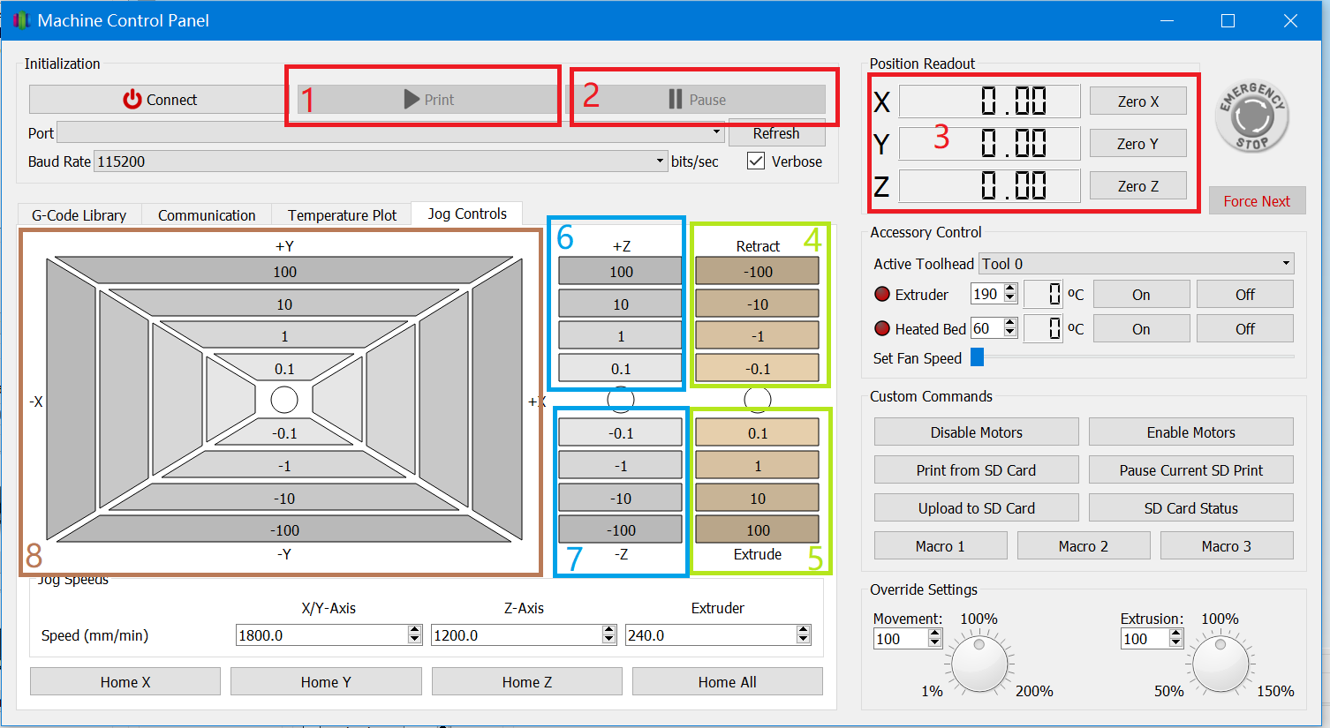
Figure 11

        - For manually control operation, you may use the system interface. Concepts are the same. However, recording your Position Readout may be inconvenient. A good method will be memorizing how many times you have pressed the position keys in which direction. You also need to move the nozzle further away from your print. Then, unload the leftover filament and load a new spool of material, using FFC’s build-in loading and unloading mechanism. A careless operation may permanently ruin your print.

Post Processing
  - This author had success with the following tutorials and guides. Please protect yourself.
    - Filing
    - Painting

Maintenance
  - Bed Leveling
    - This is the MOST important step. The cohesiveness of your first layer determine whether you have a successful print or not.
    - Flashforge Creator pro implement 3 point leveling system. The leveling technique can be found in the dark red folder located in the first level of the file cabinet. Here is a YouTube link for the visual learners out there
  - Nozzle Replacement
    - A brass nozzle typically last for 3 months under large volume of printing. Once the nozzle passes the threshold, a cleanup and replacement is recommended.
    - A stainless-steel nozzle typically last longer. However, maintenance period of stainless steel nozzle will be dramatically shortened if large volume of exotic filament like PETG and others are used.
    - This author recommends the following providers
      - Micro Swiss
  - Filament unload and reload
    - This tutorial will give you a general idea.
  - Heated Bed
    - Scratches on PEI sheet are unavoidable. Small areas of damages can be tolerated. When small pieces of PEI sheet tilt up, just trim them and flatten the surface. Purchase new supply amazon using this link
    - It is recommended to periodically clean the heated bed. Once per 3 or 4 prints is recommended.
  - Extruder Calibration
    - When under extrusion or over extrusion are experienced, an extruder calibration is needed. Here is the link to the tutorial. Be patient, you will get there!

Troubleshoot
  - Troubleshooting is painful. The more experience you have, the faster you will solve your problems. Just be patient, you will find the cure!
  - Good Website
    - All3DP
    - Simplify3D
    - Matterhackers

Useful resources
  - Youtubers
    - They have great 3D printer 101 videos and some tricks and hacks.
    - 3D printing Nerd
    - FLASHFORGE 3D PRINTER
    - Thomas Sanladerer
    - Maker Muse
  - Websites
    - Simplify3D
    - Ultimaker
    - Flashforge 3D printer
    - Prusa Research

30 commonly used words for 3D printing
from: https://www.sculpteo.com/en/glossary/

3D Bioprinting:
3D bioprinting is the process of creating living cell patterns, like skin or organs, using 3D printing. It’s generally used to regenerate and transplant organs in the medical field. As you may guess, this process is extremely complex.

3D Model:
A 3D model is a digital file representing an object in three dimensions. It is designed thanks to a 3D modeling software and can then be printed with a 3D printer. It is generally displayed as a two-dimensional model using 3D visualization.

3D Printing Resolution:
The 3D printing resolution corresponds to the accuracy of the 3D printers. It mostly relates to layer thickness. It depends on the material and technology used.

3D Printing Volume:
The 3D printing volume of a printer is the maximum size one object can have to be 3D printed by this machine. It depends on the material used, on the technique, and on the finishing options chosen.

ABS:
ABS plastic (Acrylonitrile Butadiene Styrene) is a thermoplastic polymer. This material is mainly used for personal 3D printing, with FDM or FFF techniques. It’s lightweight, with a good impact strength, and it’s affordable. Since its melting temperature is quite low (200°C/ 392°F), it can be considered as relatively safe.

Additive Manufacturing:
Additive manufacturing is another common way to call 3D printing.

Binder Jetting:
Binder Jetting is 3D printing technique which creates parts additively, with a binding agent. It can be used both for metal and for plastic. For metal, it’s the fastest technology and one of the cheapest.

CAD:
Computer Aided Design is the use of a computer software in order to create, manipulate, analyze and optimize a 2D or 3D design. It is commonly referred as CAD. It is generally used to make 2D designs for technical engineering and architecture or to make 3D designs for digital applications like animation or for manufacturing and prototyping processes like 3D printing.

CLIP:
CLIP stands for Continuous Liquid Interface Production. This 3D printing technology works by projecting a continuous sequence of UV images, generated by a digital light projector, through an oxygen-permeable, UV transparent window, below a liquid resin bath. It creates a dead zone above the window which maintains a liquid interface below the part. Above this dead zone, the cured part is drawn out of the resin bath. This 3D printing technology was first introduced in February 2014. A few months later, the company Carbon 3D was created to commercialize it.

DLP:
Digital Light Processing is a 3D printing technique where a projector is used to cure photopolymer resin. It is very similar to SLA, with a slight difference: it uses a light bulb, not an UV laser. Objects printed with this technique have less visible layers. Moreover, it is a faster technique. It is mainly used to 3D print highly detailed artworks and non-functional prototypes.

DMLS:
Direct Metal Laser Sintering is an additive manufacturing technique for metal 3D printing. It was developed by EOS. This technology uses a laser as a power source to sinter metal powder by aiming a laser and tracing a cross-section of the object, layer by layer. With DMLS, you can 3D print highly complex geometries. Its main benefits are that no tooling is required and that parts can be 3D printed quite quickly.

Extruder:
Also called Printer head, the 3D extruder is the part of a 3D printer which ejects material in semi-liquid or liquid form, to deposit it in successive layers. In some cases, it can be used only to deposit a bonding agent to solidify a material that is in its powder form.

Fab Lab:
A Fab Lab, an abbreviation for FABrication LABoratory, is a place dedicated to digital fabrication, directed by a collective community. There, you can find computer-controlled machines, and sometimes 3D printers. To use the name “Fab Lab”, the place has to respect MIT’s rules.

Filament:
The plastic used by FDM 3D printers comes in the form of a plastic filament. It is generally sold in spools and usually provided by the printer’s manufacturer. The most common materials you can find in this format are ABS, PLA, PVA and TPU.

FDM:
Fused Deposition Modeling, also called Fused Filament Fabrication (FFF), is probably the most popular 3D printing technology due to the important number of this type of 3D printers available on the market. It is an affordable 3D printing process compared to other technologies. During this process, the material is melted and extruded through a nozzle to 3D print, each layer at a time.

Layer:
In the context of 3D printing, a layer is each individual planar section of the object that is 3D printed. Before being 3D printed, the object is sliced in a large number of horizontal layers that will be manufactured in an ordered sequence, each layer adhering to the previous one, to then form a 3D structure.

Layer Thickness:
Layer thickness is the measure of the height of each successive addition of material in the 3D printing process. It is an essential technical element of any 3D printer. Generally, it is between 16 µm and 150 µm.

LOM:
Laminated Object Manufacturing is an inexpensive and very fast way to 3D print objects. It is available for several kinds of materials, but mostly for paper. Sheets are bonded together and then cut in the geometry of the 3D model. This process is mainly used for rapid prototyping, not production.

Multijet:
Multijet is a color 3D printing process which uses an UV light to crosslink a photopolymer, like Stereolithography. However, it is different from it since a printer head throws little droplets of the photopolymer (like in the ink in an inkjet printer) in the shape of the first layer, instead of using laser scanning to cure layers. An UV lamp, attached to the printer head, crosses the polymer and locks its shape. This process creates high resolution and highly complex parts, but it 3D prints elements that are less strong than SLS and FDM.

Photopolymerization:
Photopolymerization is the process of solidification of a photosensitive resin, using an UV light. This technique is used in various 3D printing processes like DLP, SLA, and Multijet.

PLA:
PLA, also called Polylactic Acid, is a plastic material which is vegetable-based. The raw material it commonly uses is cornstarch. It’s the first natural raw material used in 3D printing. This thermoplastic polymer is fully biodegradable. It is a standard material for the FDM technology, along with ABS. It has a good geometrical stability during manufacturing, but it is less durable and more fragile than ABS. Therefore, it is perfectly suited for decorative objects, with no mechanical parts.

Polyamide:
Polyamide is a plastic material often used for 3D printing. It is also known as Nylon. Depending on the technique, it can be used in different forms. For instance, it is used in powder form for SLS, but it’s heated until it becomes liquid for FDM. Its properties allow both prototyping and production.

Polyjet:
Polyjet is a color 3D printing process, like Multijet. This technique is the most similar to 2D printing. A printer head deposits a layer of material, and then another one deposits glue before printing another layer above it. Glue and color can be applied at the same time, or later. It is a cheap technique, easy to use, allowing the creation of little objects and figurines.

Printer Bed:
The printer bed is the flat part of a 3D printer where the object stands during the whole 3D printing process. It can be fixed or moving, depending on the machine and on the 3D printing process used.

SDL:
Selective Deposit Layers is a 3D printing process using paper. It involves layers of adhesive coated paper (or plastic, or metal), glued together and cut to shape with a laser cutter, layer per layer. A roller moves each sheet of material over the last one until the object is totally 3D printed. Since you can use basic paper with this technique, it is a way to 3D print at a low cost. It is quite similar to the LOM technique, but the gluing process is different: in SDL, only the parts that will make the object are glued, while in LOM the entire sheet is glued uniformly.

SLA:
Stereolithography (SLA) is a 3D printing process for resin. A vat of photopolymer resin is exposed to an UV light laser, heating selected parts of it, layer per layer. SLA objects don’t have the strength of objects 3D printed with SLS and FDM technologies, but it allows a higher level of details. Thus, it is mainly used for not functional prototypes and highly detailed artworks.

SLM:
Selective Laser Melting is a 3D printing technique that allows to 3D print metal. A laser melts successive layers of metallic powder in specific places in order to create the 3D object wanted. With SLM, you can create highly complex parts. Thus, it is commonly used in the aeronautic sector.

SLS:
Selective Laser Sintering is a 3D printing technique. Powder material, typically Nylon, is transferred inside the 3D printer. Then, a laser selectively heats some parts of powder layers, in order to create the shape desired. Compared to other additive manufacturing techniques, SLS doesn’t require support structures since the powder acts as self-support. This allows the construction of complex geometries.

Thermoplastic:
Thermoplastic is a polymer material which softens when it is heated, and then solidifies when it cools. It is used for plastic 3D printing, especially with the SLS technology.

Wax:
3D printed wax is used to make molds, using the 3D Lost Wax Casting technique. It then allows creating high-quality jewelry in metal. How does it work? The 3D model of the object is Wax 3D printed, layer by layer. A mold is then built around the wax object. Afterward, the wax is melted and removed in order to obtain an empty space in the mold, corresponding to the final object. Finally, the empty space is filled with molten metal in order to get the final object.

